16/10/2021 – Action plan to do

* MVP for app
* App requirements
* Presentation – Project objectives, implementation plan, Risks, context
* Work Breakdown
* Milestone identification
* Activity Network

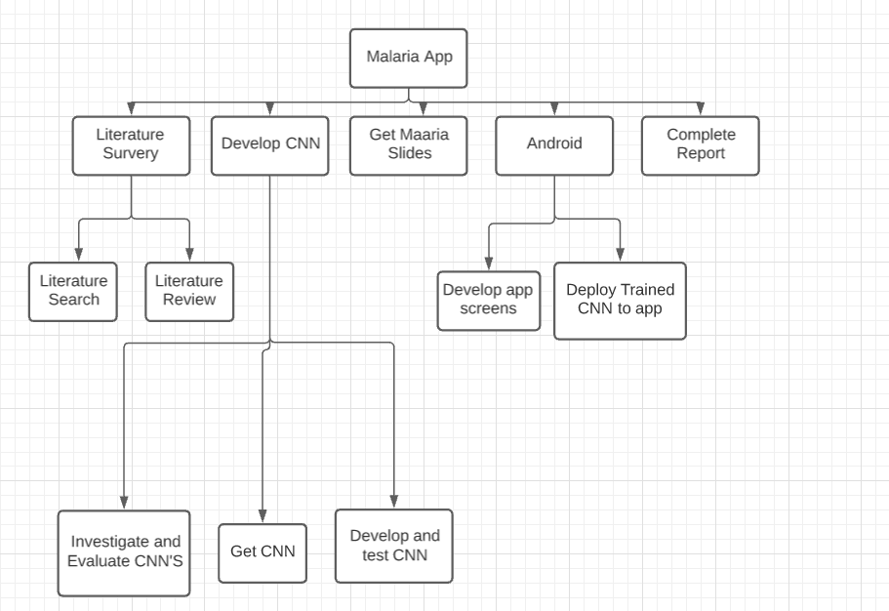

|  |  |
| --- | --- |
| Activity | Estimate Duration |
| Literature Search | 4 weeks |
| Literature review | 2 weeks |
| Investigate and evaluate CNN’s | 1 weeks |
| Get CNN’s | 2 days |
| Develop and test CNN’s | 8 weeks |
| Get malaria Slides | 2 days |
| Develop App screens | 4 weeks |
| Deploy trained CNN to app | 2 weeks |
| Complete Report | 3 weeks |
| Total Effort | 26 weeks (approx. 7 months) |

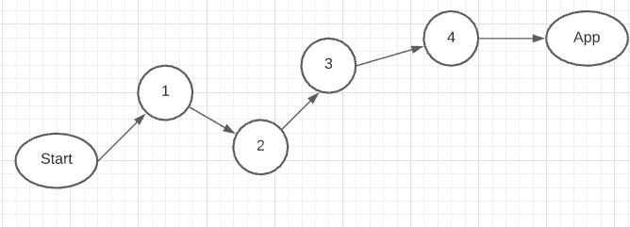

Milestones – Literature, Developed CNN, CNN on the app , APP pages complete,

Project risks – Keeping medical data and privacy,